Job Webinar: https://youtu.be/Cpw_c4AzM6E?si=FCnk-KTUnWu4-Omw

Additional position information: https://www.federalregister.gov/documents/2024/07/29/2024-16571/statement-of-organization-functions-and-delegations-of-authority-office-of-the-national-coordinator

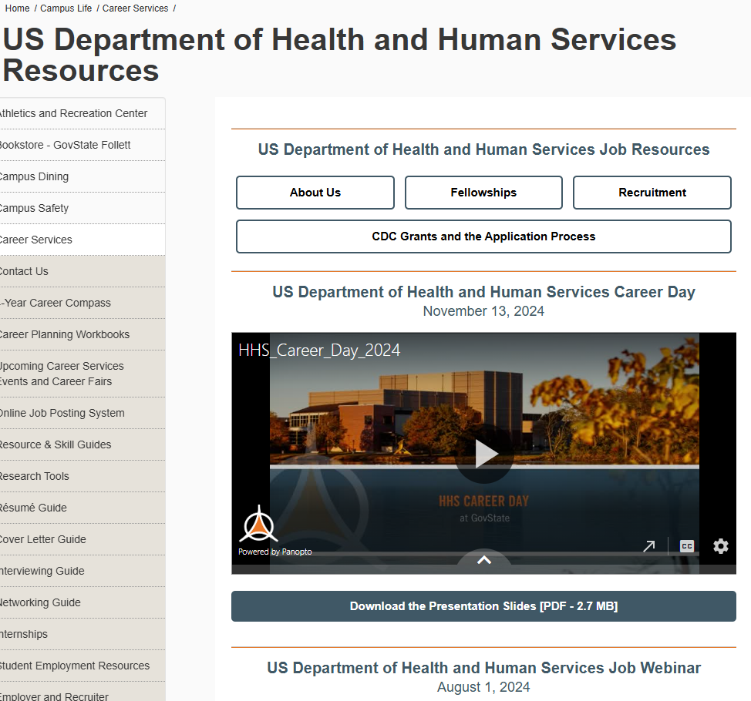
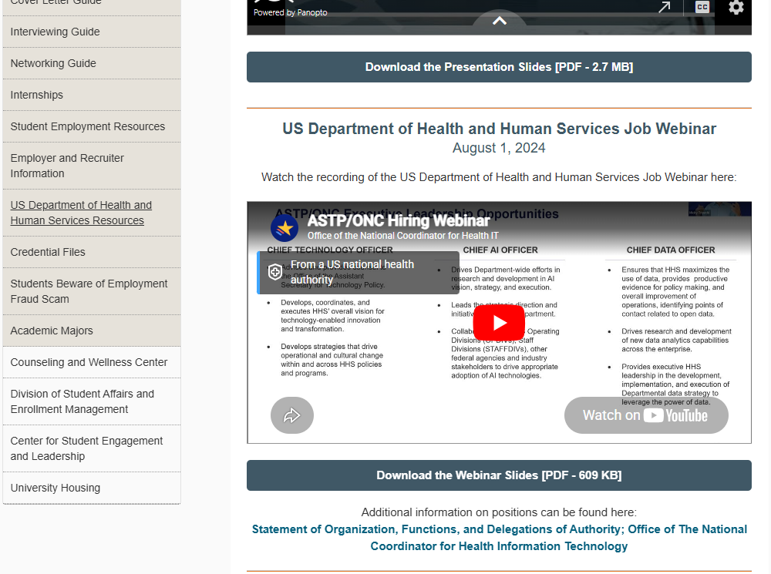

HHS Career day is panopto

